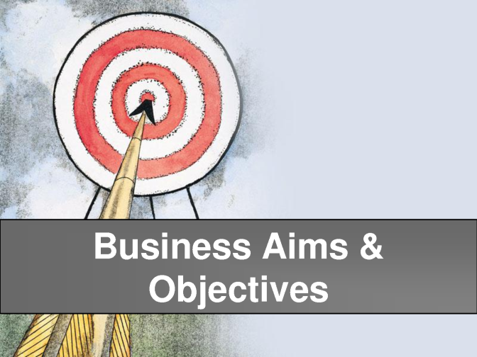
Businesses have different aims and objectives that can change over time
Extension task: Now complete exam style questions on page 12 of the text book (26 Marks available)
Describe what is meant by a business aim and give an example:

Revision sheet 1: Business aims & Objectives
How do the aims of public sector organisations differ from those of private sector organisations? Give an example for each.

Private:

Public:

List at least five business aims that a business might like to achieve
1.
2.
3.
4.
5.
What is the most likely short term objective for new businesses? Give a specific example
Describe what is meant by a business objective and give an example:

Explain why business objectives change over time, give a specific example
Describe what is meant by SMART

Explain SMART
Using a business example:
S

M

A

R

T

Past exam question:
Explain one reason why businesses use objectives.
..........................................................................................
..........................................................................................
..........................................................................................
..........................................................................................
(2 marks)

