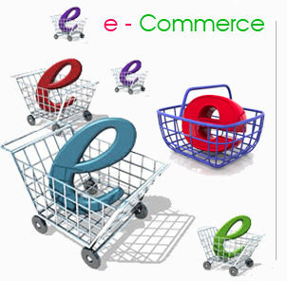

Describe what is meant by ecommerce and give an example:

**How Businesses use the internet & Cost and Benefits**

Websites can give and receive information give 3 examples of the type of information given and received.

Given:

Received:

Revision sheet Ecommerce

Websites can reduce cost, explain how this is possible and give 3 examples:

BUT for some the cost is greater than the savings, explain why this might be and give specific examples:

The internet creates all sorts of opportunities for business, explain why using examples.

Explain how the internet can provide marketing opportunities:

Websites can provide customer service; explain at 3 ways in which this can be achieved.

1.

2.

3.

**Give2 examples of successful business websites and explain why you believe them to be so.**

**Why can having a website give a business more to worry about, give 2 examples?**



Explain the law that stops people copy material without permission?

1. What is an IP address, explain?
2. Why are domain names used?
3. What can a domain name register tell you?
4. Explain some of the rules around using domain names?
5. Is a domain name free?
6. **Websites are hosted on servers-how are these managed?**

1. Who looks after the servers?

1. Do all websites have to be on the internet? explain

**How Businesses use the internet Domain names, hosting & the law**

Explain what a Domain name is?

Revision sheet Ecommerce

Explain the law with regards to Personal data collected by a firm?

What 2 laws ensure that business selling over the internet do so legally?

1.

2.

Give some examples of what the laws state products sold by a business must be?

What is the law that covers distant selling?

What are the 3 main right customers have under this law?

1.

2.

3.

What is an encrypted page?



Extension task: Complete the exam style questions on page 98 of the text.

**Develop & Test, once the planning is done this needs to take place.**

**Give some examples of technical development and testing, explain why using examples.**

**What is meant by rollout?**

**Explain why websites need to be maintained and give an example.**

**Users and their equipment:**

In the box below draw a basic design for a web page and annotate the features

**How Businesses use the internet: Creating a website**

**Content:**

**Budget:**

Before you create your business website careful consideration needs to be taken including budget, content, users and their equipment.

Summarise these below:

Revision sheet Ecommerce